Lab 0. Setting up the experimental designer & activate your community license

Task: Select the new Power Automate Designer

At the time of writing the new Flow designer is still in experimental stage. To select the new designer,

1. go to **flow.microsoft.com**,
2. select the **setting**s button:

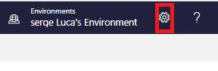

1. Select **View all Power Automate settings**:

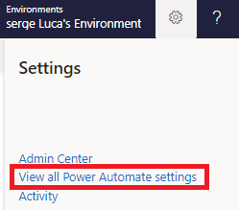

1. Check the option **Experimental Features**:

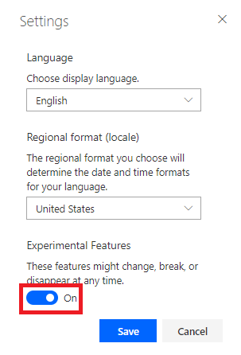

1. Click **Save**.

Task: Activate your Community license

The Office 365 license provides you with a Standard Power Apps and Power Automate license which is good enough for most labs. However, some labs require a Premium connector; the Community license give you access to **Premium features** of the product for free. The main restriction with the Community license is that flows, and applications created with the Community license cannot be shared with other users.

Go to <https://powerapps.microsoft.com/en-us/communityplan/> and click Get started for free

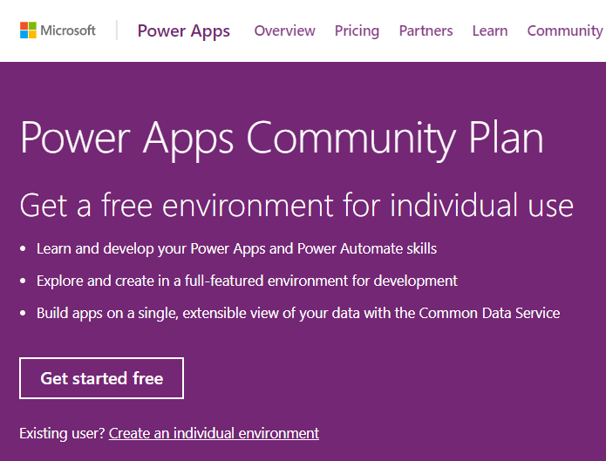

1. Enter your e-mail address:

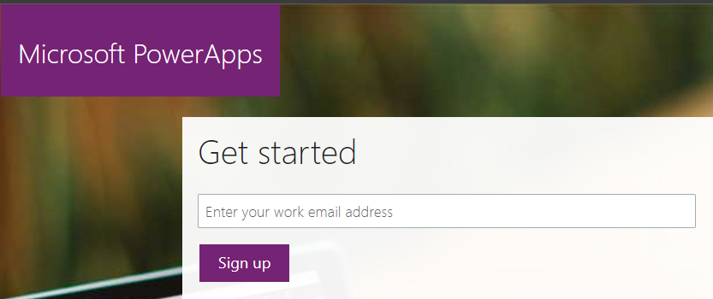

1. And Sign-in:

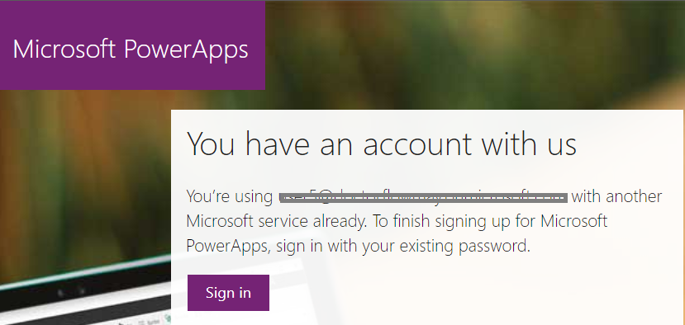

Click Start:

